Project Design Phase-II
Technology Stack (Architecture & Stack)

Date | 30 September 2026
Team ID | SWTID-2026-3555
Project Name | AI Study Buddy
Maximum Marks | 4 Marks

Technical Architecture:
The Deliverable shall include the architectural diagram as below and the information as per the table1 & table 2
AI Study Buddy – Technical Architecture:
Reference: https://developer.ibm.com/patterns/ai-powered-backend-system-for-order-processing-during-pandemics/

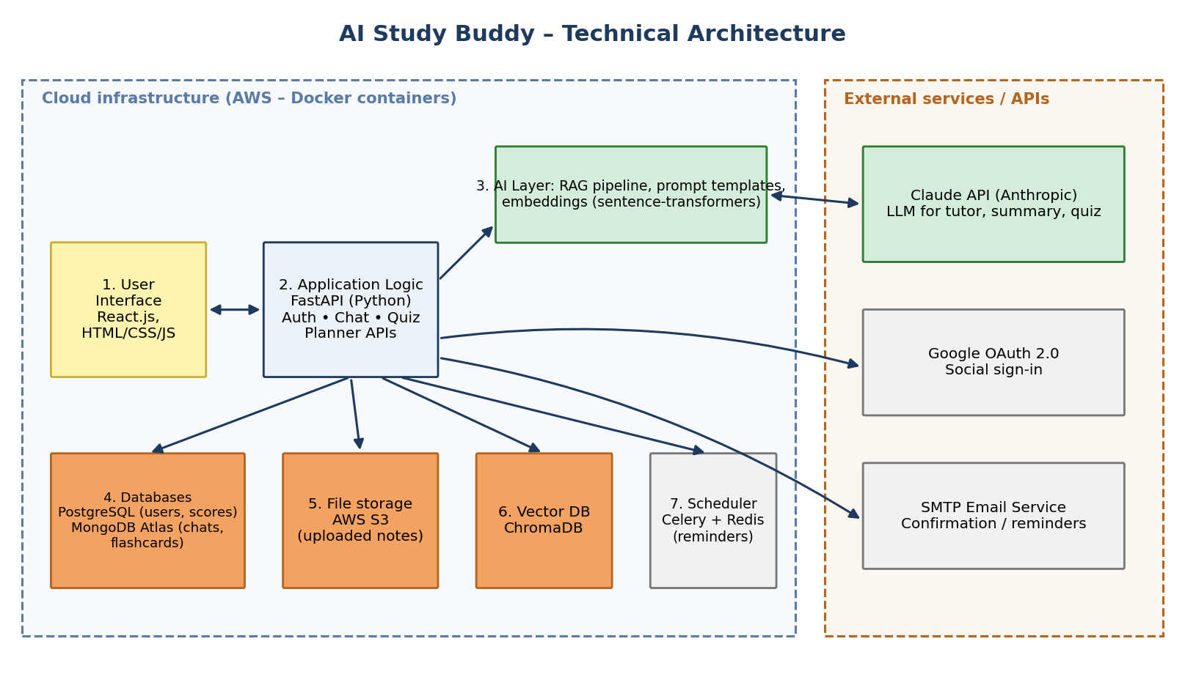
Table-1 : Components & Technologies:
S.No | Component | Description | Technology
 | User Interface | Web UI where students chat with the AI tutor, upload notes, take quizzes, view planner and dashboard (responsive for mobile) | HTML, CSS, JavaScript, React.js
 | Application Logic-1 | Backend REST APIs: authentication, users, notes, quizzes, planner and progress logic | Python, FastAPI
 | Application Logic-2 | AI orchestration: prompt building, retrieval-augmented generation (RAG), guardrails, response formatting | Python, LangChain-style pipeline
 | Application Logic-3 | Background jobs: email confirmations and study reminders | Celery, Redis
 | Database | Relational data: users, quiz results, study plans, progress records | PostgreSQL
 | Cloud Database | Chat history and flashcards (document data) on cloud | MongoDB Atlas
 | File Storage | Storage of uploaded notes (PDF / DOCX) | AWS S3
 | External API-1 | Large language model for tutoring, summaries, quizzes and flashcards | Claude API (Anthropic)
 | External API-2 | Social sign-in with Gmail | Google OAuth 2.0 API
 | Machine Learning Model | Text embeddings for semantic search over student notes (RAG) and vector similarity search | sentence-transformers, ChromaDB
 | Infrastructure (Server / Cloud) | Application deployment on cloud using containers.  Local: Docker Compose for development.  Cloud: AWS EC2 / ECS with Docker, Nginx reverse proxy | Docker, AWS, Nginx

Table-2: Application Characteristics:
S.No | Characteristics | Description | Technology
 | Open-Source Frameworks | React.js, FastAPI, Celery, ChromaDB, sentence-transformers, Docker | React, FastAPI, Celery, ChromaDB
 | Security Implementations | Password hashing, JWT tokens, HTTPS/TLS, OAuth 2.0, input validation, file-type checks, rate limiting, secrets in environment variables | bcrypt, JWT, TLS, OAuth 2.0, OWASP guidelines
 | Scalable Architecture | 3-tier architecture (UI, API, data) with stateless API containers that can be replicated; AI and background jobs separated from the API | 3-tier, Docker, AWS ECS
 | Availability | Load balancer with multiple API instances, health checks, auto-restart and database backups | AWS Load Balancer, Docker health checks
 | Performance | Caching of frequent queries, streaming of AI responses, vector search for fast retrieval, CDN for static assets | Redis cache, ChromaDB, CDN (CloudFront)

References:
https://c4model.com/
https://developer.ibm.com/patterns/online-order-processing-system-during-pandemic/
https://www.ibm.com/cloud/architecture
https://aws.amazon.com/architecture
https://medium.com/the-internal-startup/how-to-draw-useful-technical-architecture-diagrams-2d20c9fda90d

